**STARAGILE APPLICATION DEVELOPMENT FUNDAMENTAL ASSIGNMENT**

1. **Create a Java Project:** Create a new Java project in your preferred IDE.

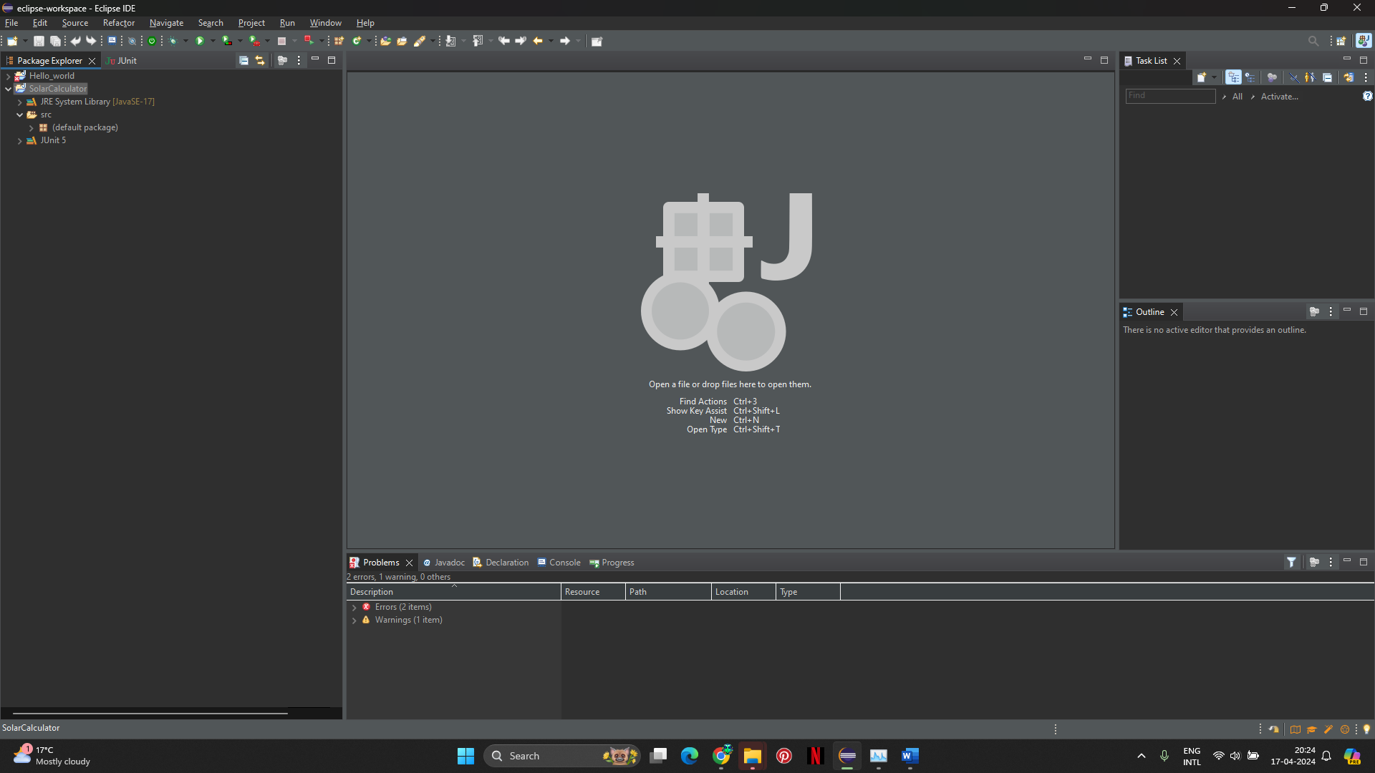

1. **Create a class Calculator.java:** Create a new class named **Calculator** within your Java project.

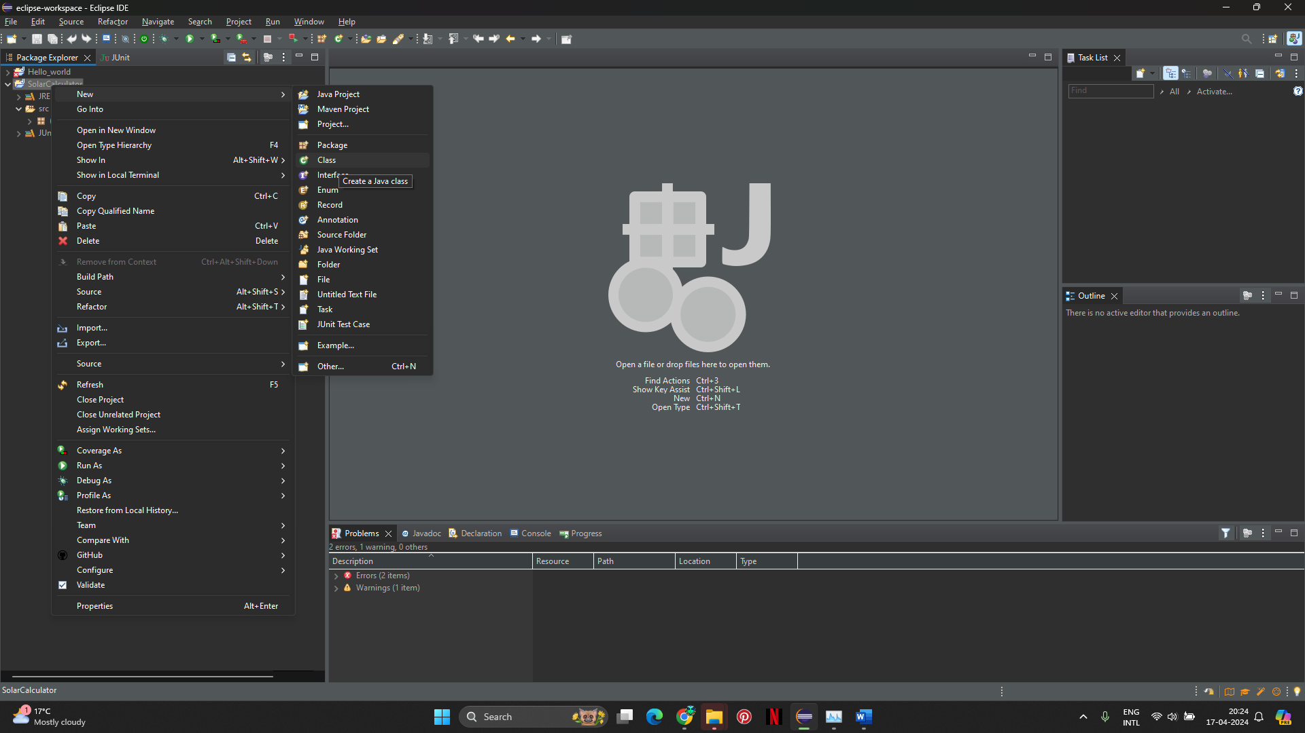

1. **Write 4 public methods (Sum, Subtract, Multiply, Divide):** Inside the **Calculator** class, write four public methods: **sum**, **subtract**, **multiply**, and **divide**, each taking two integer values as input parameters.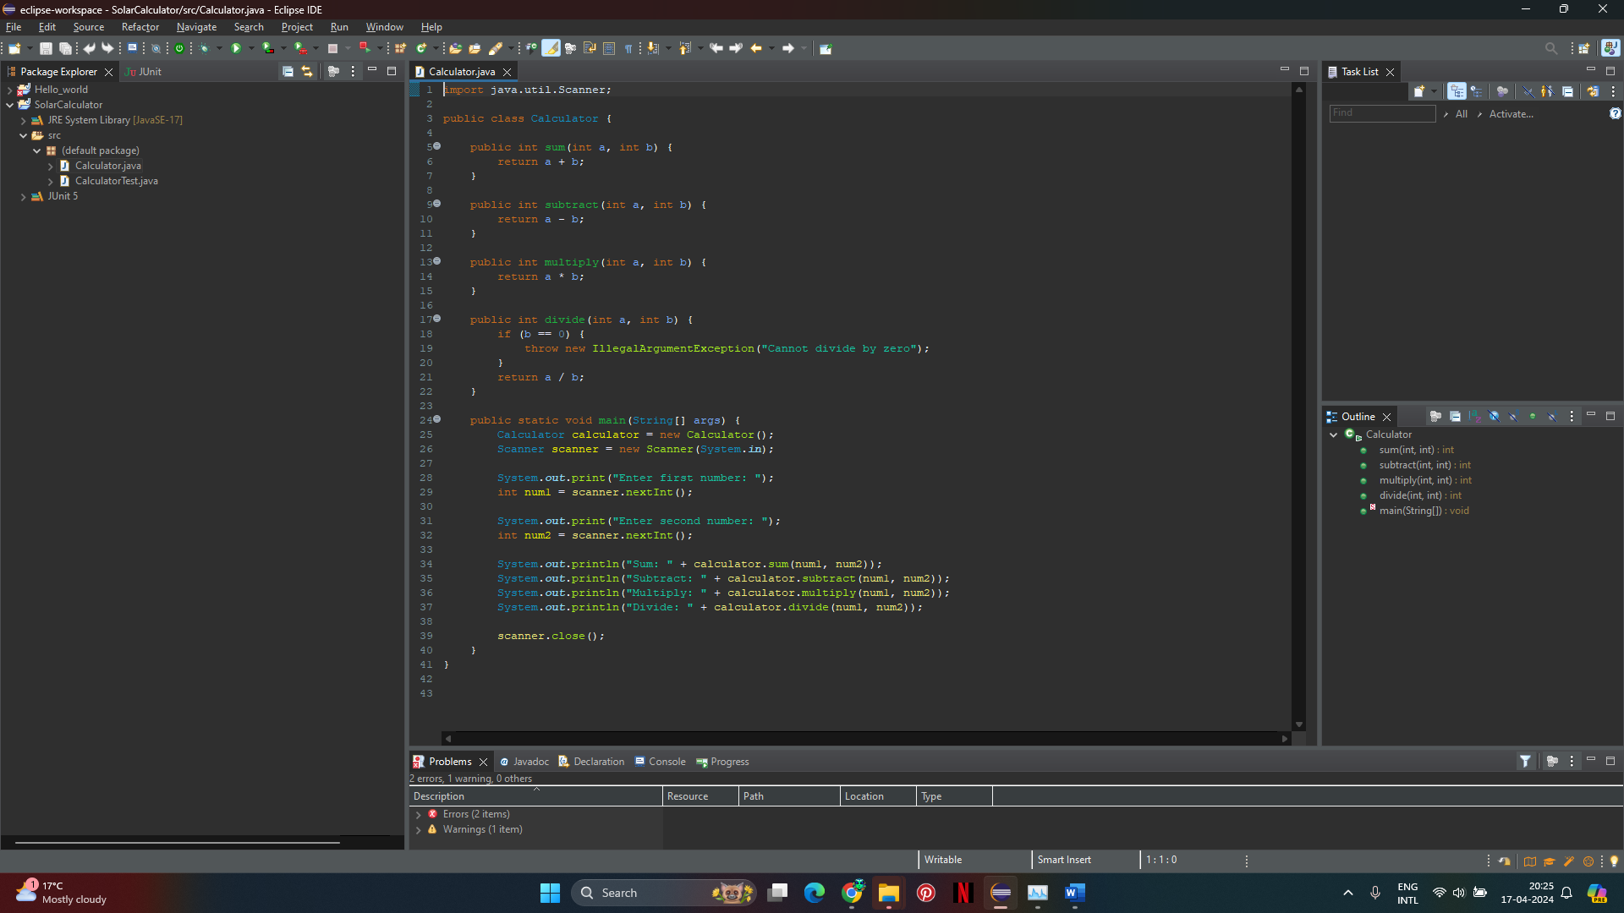
2. **Read input from the Console:** Utilize **Scanner** class from **java.util** package to read input from the console.
3. **Write the main method:** Write a **main** method in the **Calculator** class to read two input values from the terminal, call all the methods, and print the output of the methods.



Test running the project

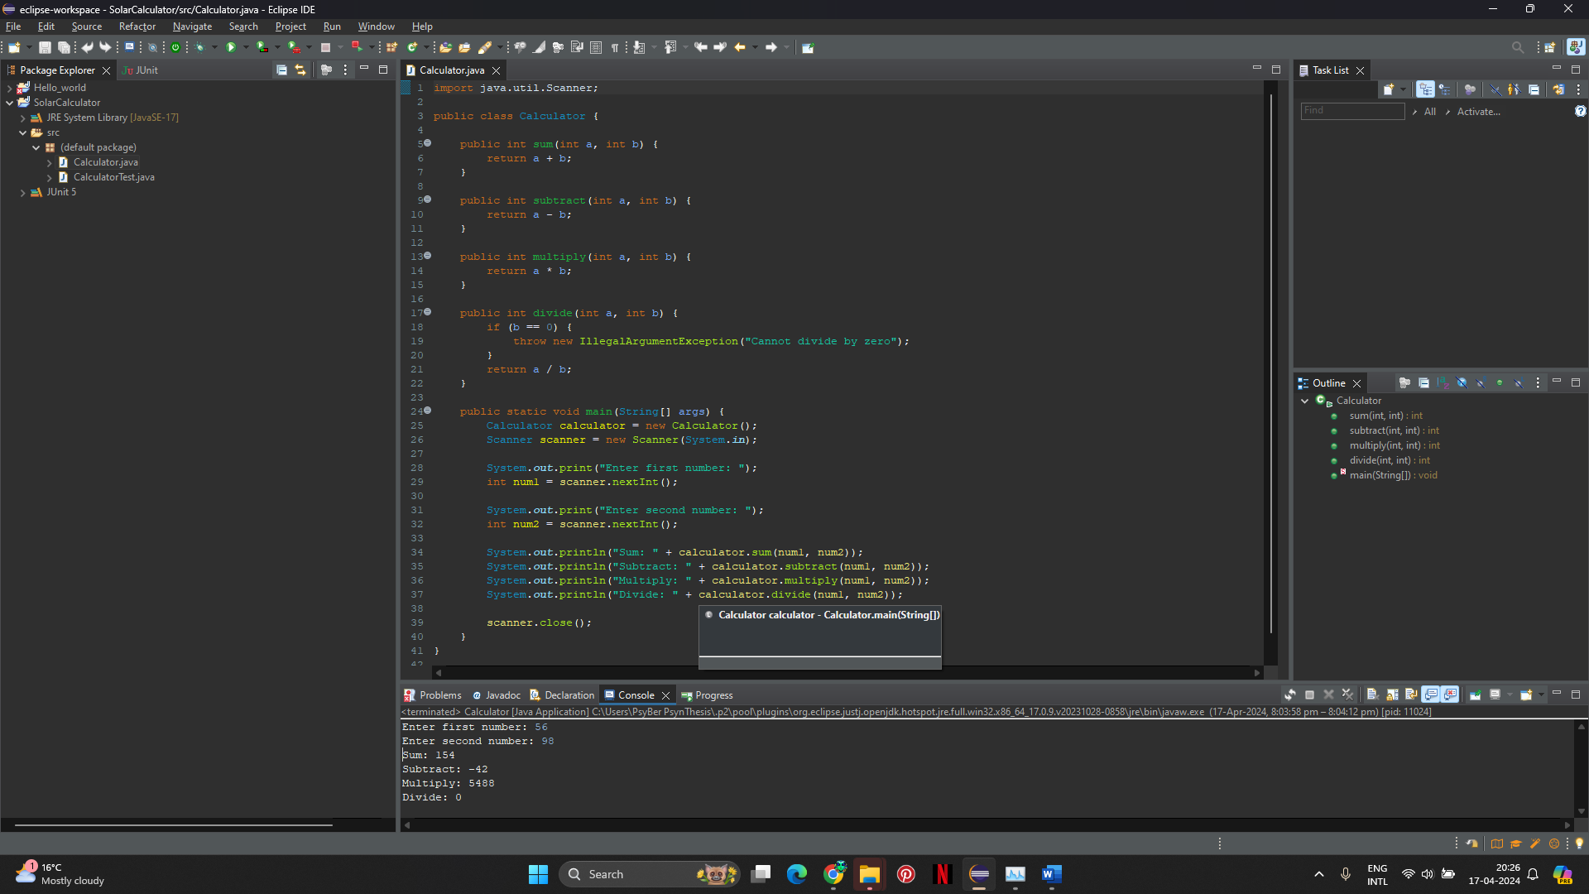

1. **Import the Junit jar:** Add JUnit library to your project. You can download the JUnit jar file and add it to your project's build path.
2. **Write JUnit test cases:** Create a new test class, let's name it **CalculatorTest**, to write JUnit test cases for each of the four methods (**sum**, **subtract**, **multiply**, and **divide**) in the **Calculator** class.

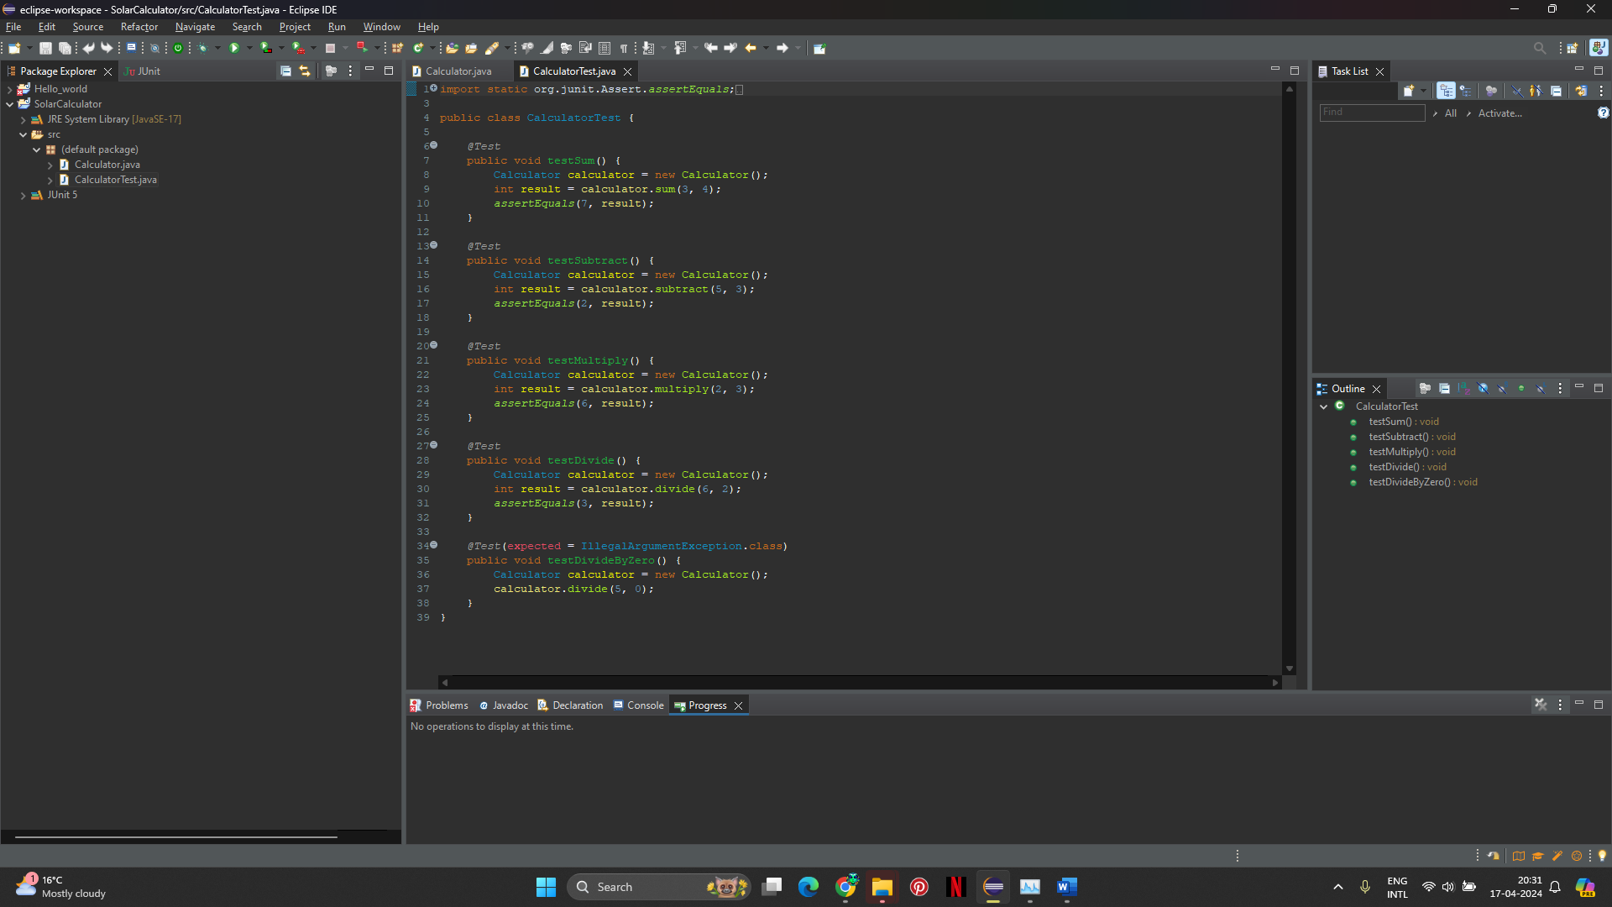

1. **Run the test cases:** Run the JUnit test cases to validate the method outputs.

